DATE : 14.12.2018
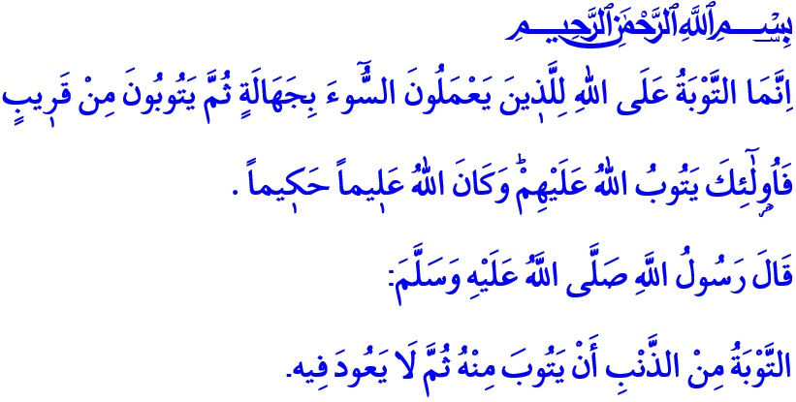MERCY AND FORGIVENESS DOOR: REPENTANCE
Esteemed Believers!
Adam (a.s.) and his wife, our mother Eve, had done a mistake in the heaven. Immediately, they became aware of their mistake and regretted it. Our Sublime Lord, had blessed them with the virtue of repentance, the virtue of returning from their mistake. They also voiced their regret; “They said, "Our Lord, we have wronged ourselves, and if You do not forgive us and have mercy upon us, we will surely be among the losers."”, They wished forgiveness from Allah. Thus, humanity learned the first instance of repentance from Hazrat Adam and his wife.
Valuable Muslims!
We're all human. Throughout our lives, we struggle with the devil who gives us evil suggestions, and our evil self which tries to refer us to mistakes. In this struggle, sometimes we fulfill the needs of our servitude; sometimes we experience skids, heedlessness and error. When we make a mistake, we do not give up hope from Allah and we open the gates of mercy with the key of repentance.
Valuable Believers!
Repentance is the gospel of salvation and purification, which Almighty Allah favored to His servants. It is the remembrance of the Lord by the servant, expression of weakness and asking forgiveness and mercy of The Supreme Allah. This is the servant's asylum to Almighty Allah, the most Merciful of the merciful. So to speak, repentance is a treat for us from Our Lord, to start life again, to open a clean page. For the believer who is caught in temptation, it is the most important guide that determines the way and direction.
Esteemed Muslims!
Allah has many names, meaning forgiveness and pardoning. He is the Tawwab; The Ever-Pardoning, Ever Relenting, he is the great accepter of repentances. He is Afuww; The Pardoner, The Forgiver, he who forgives those who take refuge in his great mercy. He is Ghafur; The All-Forgiving, forgives who wishes to be forgiven and whom he wills. He is Sattar, The Veiler, He veils errors and flaws.
The Supreme Allah never turns those who turn to Him and repent sincerely, empty handed. He never embarrasses those who sincerely submit to him. He graces His servants with His mercy. Thus, Our Sublime Lord in The Holy Qur’an commands so: “…Except for those who repent, believe and do righteous work. For them Allah will replace their evil deeds with good. And ever is Allah Forgiving and Merciful.”
Honorable Muslims!
The essence of the repentance is a sincere and cordial appeal. Our Sublime Lord commands, “O you who have believed, repent to Allah with sincere repentance…”.
The essence of repentance is the regret we feel in our hearts. The Magnanimous Prophet (s.a.w.), has expressed this fact in a hadith, saying “Regret/remorse for the sin is repentance”.
The essence of repentance is to realize our mistakes and sins as soon as possible and to turn to Almighty Allah. As it is commanded in the Holy Qur’an: “The repentance accepted by Allah is only for those who do wrong in ignorance [or carelessness] and then repent soon after. It is those to whom Allah will turn in forgiveness, and Allah is ever Knowing and Wise.”.
The essence of the repentance is perseverance to not to return to the sins, and not to be a slave of whim and ambition. Our Master Prophet (s.a.w.) described repentance as “To leave the sin, never to return it again.”.
Valuable Believers!
The repentance door is wide open. It will remain open until the last breath. So, our duty is to seek the ways of sipping the sea of mercy of Allah. With sincerity, with regret, with determination to take refuge in His mercy and miracle. In the chaos of everyday life, it is to purify our hearts and our minds. May Allah give us all awakened hearts, forgiveness and mercy, happiness in the world and Hereafter as beneficence.
I am finishing our khutbah with the prayer of Our Prophet (s.a.w.):
 “O Allah, You are my Lord, there is none worthy of worship except You, You created me and I am Your slave. I am adhering to Your covenant and Your promise as much as I am able to, I seek refuge in You from the evil of what I have done. I admit to You your blessings upon me, and I admit to my sins. So forgive me, for there is none who can forgive sins except You.”

A’raf, 7/23.
Furqan, 25/70.
Tahrim, 66/8.
Ibn Hanbal, I, 423.
Nisa, 4/17.
Ibn Hanbal, I, 446.
Tirmidhi, Supplication, 15. General Directorate of Religious Services

